**VISVESVARAYA TECHNOLOGICAL UNIVERSITY**

"Jnana Sangama", Belagavi - 590018

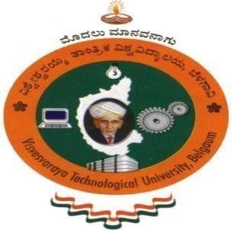

A Report on

### AICTE ACTIVITY

**NON CREDIT MANDATORY COURSE**

Submitted in partial fulfillment of the requirement for the award of the degree of

### Bachelor of Engineering in

**Computer Science and Engineering**

**By Anish Kumar**

**1AY21CS028**

Under the guidance of

### Mrs. VARALAKSHMI B D

**Assistant Professor**

**Department of Computer Science and Engineering**

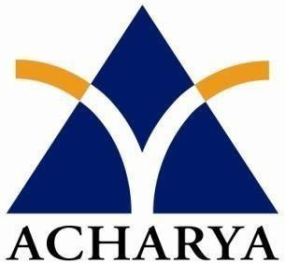

**DEPARTMENT OF COMPUTER SCIENCE AND ENGINEERING**

**ACHARYA INSTITUTE OF TECHNOLOGY**

(Affiliated to Visvesvaraya Technological University, Belagavi)

2023-2024

**ACHARYA INSTITUTE OF TECHNOLOGY**

Acharya Dr. Sarvepalli Radhakrishnan Road, Soladevanahalli, Bengaluru – 560107 (Affiliated to Visvesvaraya Technological University, Belagavi)

**DEPARTMENT OF COMPUTER SCIENCE AND ENGINEERING**

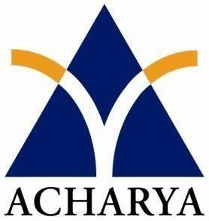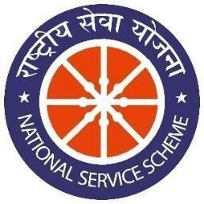

# CERTIFICATE

Certified that the report entitled **AICTE ACTIVITY - Promoting Digital Moeny in Abbigere, Bangalore** activity carried out by **Anish Kumar (1AY21CS028)** in partial fulfillment for the award of degree of **Bachelor of Engineering in Computer Science and Engineering of Visvesvaraya Technological University**, **Belagavi** during **3rd semester** in the year **2023-2024.** It is certified that all corrections/suggestions indicated for internal assessments have been incorporated in the report deposited in the departmental library. The activity report has been approved as it satisfies the academic requirements in respect of project prescribed for the **Bachelor of Engineering Degree**.

|  |  |  |
| --- | --- | --- |
| Signature of NSS Coordinator | Signature of HOD | Signature of Principal |
| **Mrs Varalakshmi B D** | **Dr. Ajith Padyana** | **Dr. Rajath Hegde. M.M** |
| **Assistant Professor** | **HOD** | **Principal** |

**Aicte Officer, AIT**

**External**

**Name of Examiner** **Signature with Date**



# DECLARATION

I student of 6th semester, B.E Computer Science and Engineering, Acharya Institute of Technology, Bangalore, hereby declare that the activity report entitled **“AICTE Activity**

**- Promoting Digital Money in Abbigere, Bangalore”** is an authentic activity report of our own work carried out under the supervision and guidance of Mrs. Varalakshmi B D, Assistant Professor and Aicte CSE Department Coordinator, Department of Computer Science and Engineering, Acharya Institute of Technology, Bangalore. I have not submitted the matter embodied to any other University or Institution for the award of any other degree.

Date:

Place: Bengaluru

**Anish Kumar 1AY21CS028**

# ACKNOWLEDGEMENT

I express my gratitude to my institution and management for providing me with good infrastructure, laboratory, facilities and inspiring staff, and whose gratitude was of immense help in completion of this report successfully.

I am deeply indebted to **Dr. C.K Marigowda** Principal, Acharya Institute of Technology, Bengaluru, who has been a constant source of enthusiastic inspiration to steer me forward.

I heartily thank **Prof. Rajeev Bilagi**, Head of the Department, Department of Mechanical Engineering, Acharya Institute of Technology, Bengaluru, for his valuable support and for rendering me resources for this activity.

I specially thank **Mrs. Varalakshmi B D,** Assistant Professor and NSS CSE Department Coordinator, Department of Computer Science and Engineering, Acharya Institute of Technology, Bangalore who guided me with valuable suggestions in completing this project at every stage.

I would like to express my sincere thanks and heartfelt gratitude to Computer Science and Engineering staff members, my beloved Parents, Respected Professors, Classmates, Friends and non-teaching staff for their indispensable help at all times.

Last but not the least our respectful thanks to the Almighty.

**Anish Kumar 1AY21CS028**